**Room FSM状态图：**

R N

·E

·W

000 001

·N ·S 101

·V

·W ·E

011 ·E 010 100 ·V

110

**Room FSM状态/输出表：**

|  |  |  |  |
| --- | --- | --- | --- |
| Clk | 现态  S6n~S0n/swn | 输入  nsew | 次态  S6n+1~S0n+1/swn+1 |
| ↑ | 0000001/0 | 0010 | 0000010/0 |
| ↑ | 0000010/0 | 0001 | 0000001/0 |
| ↑ | 0000010/0 | 0100 | 0000100/0 |
| ↑ | 0000100/0 | 1000 | 0000010/0 |
| ↑ | 0000100/0 | 0010 | 0010000/0 |
| ↑ | 0000100/0 | 0001 | 0001000/1 |
| ↑ | 0010000/0 | xxxx | 1000000/0 |
| ↑ | 0001000/1 | 0010 | 0000100/1 |
| ↑ | 0000100/1 | 0010 | 0010000/1 |
| ↑ | 0010000/1 | xxxx | 0100000/1 |
| ↑ | 0000100/1 | 1000 | 0000010/1 |
| ↑ | 0000010/1 | 0001 | 1000000/1 |
| ↑ | 1000000/1 | 0010 | 0000010/1 |
| ↑ | 0000010/1 | 0100 | 0000100/1 |

**Sword FSM状态/输出表：**

|  |  |  |  |
| --- | --- | --- | --- |
| Clk | 现态  Vn | 输入  reset/sw | 次态  Vn+1 |
| ↑ | 0 | x/0 | 0 |
| ↑ | 0 | 0/1 | 1 |
| ↑ | 1 | 0/x | 1 |

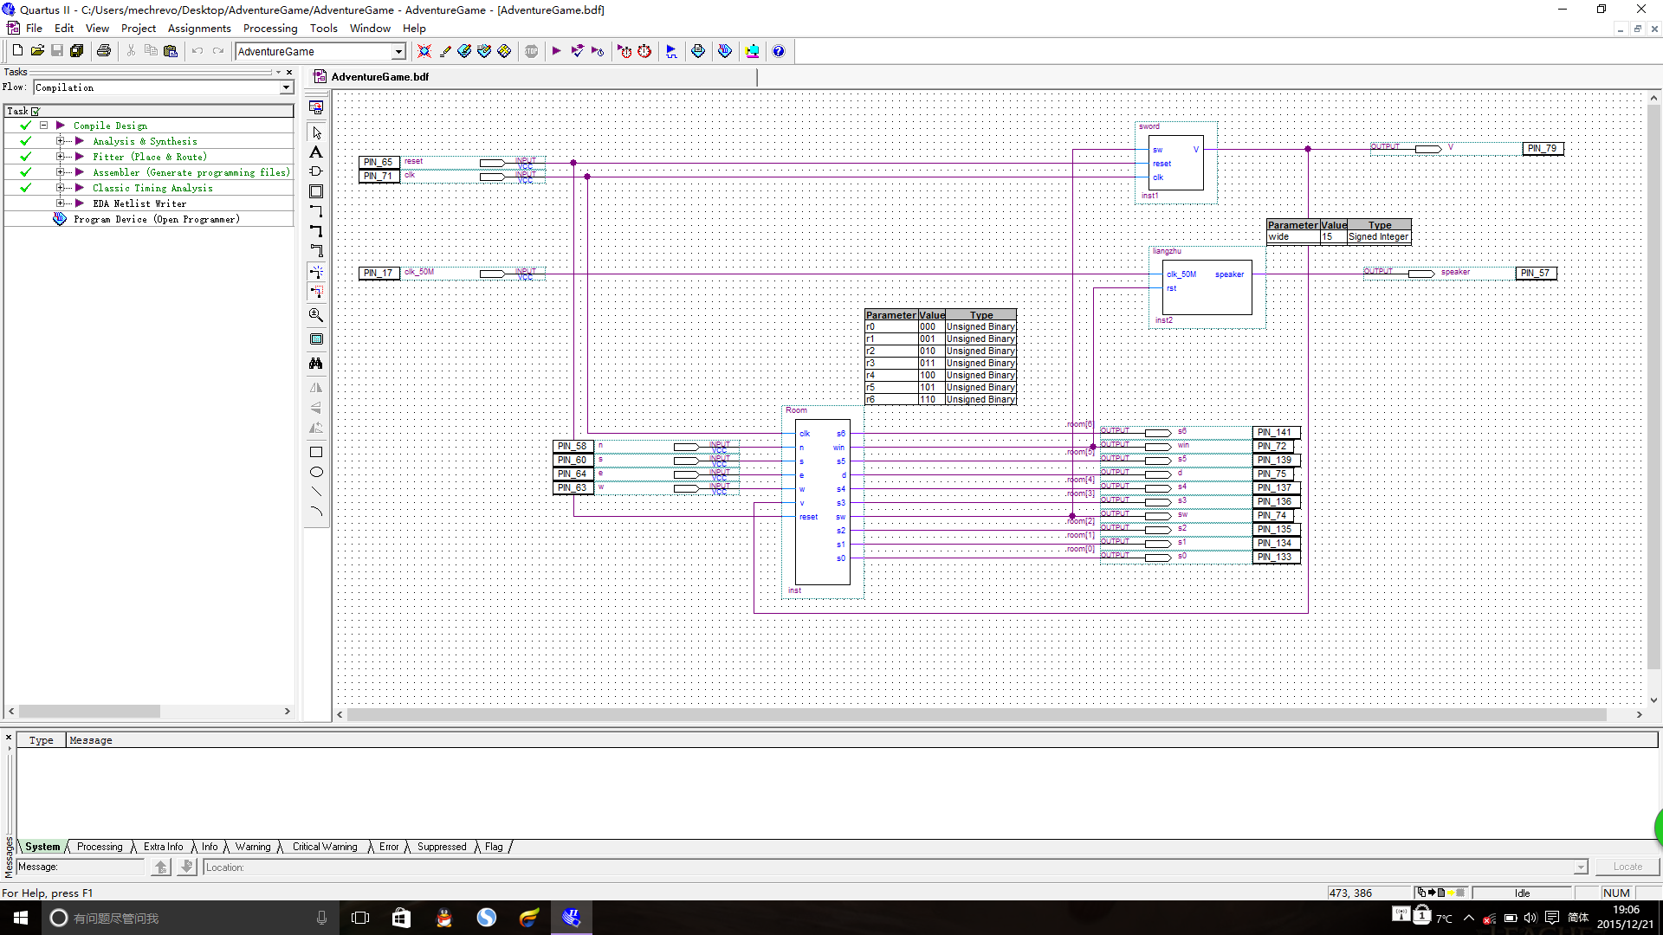

Win:

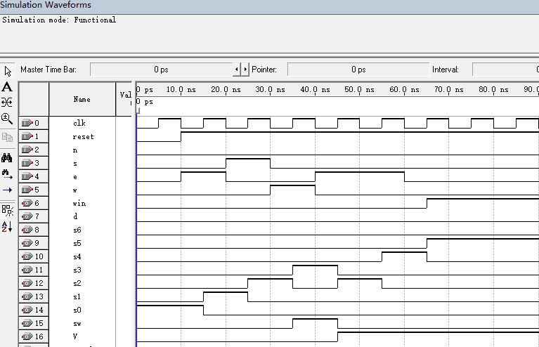

Dead:

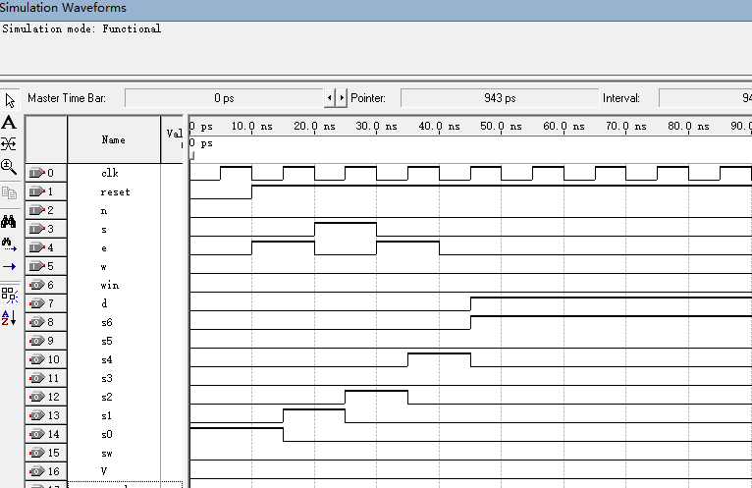

引脚

|  |  |  |
| --- | --- | --- |
|  | 主板器件名 | EP2C8T144 |
| Clk | P12 | P71 |
| reset | 键5 | P65 |
| n | 键1 | P58 |
| s | 键2 | P60 |
| e | 键4 | P64 |
| w | 键3 | P63 |
| win | 键9 | P72 |
| dead | 键10 | P75 |
| s6 | D6 | P141 |
| s5 | D5 | P139 |
| s4 | D4 | P137 |
| s3 | D3 | P136 |
| s2 | D2 | P135 |
| s1 | D1 | P134 |
| s0 | D0 | P133 |
| sw | 键11 | P74 |
| V | 键12 | P79 |
| speaker | 扬声器 | P57 |
| Clk_50M | 50MHz | P17 |

获胜后会蜂鸣器播放梁祝音乐。

运行结果照片

开始游戏：

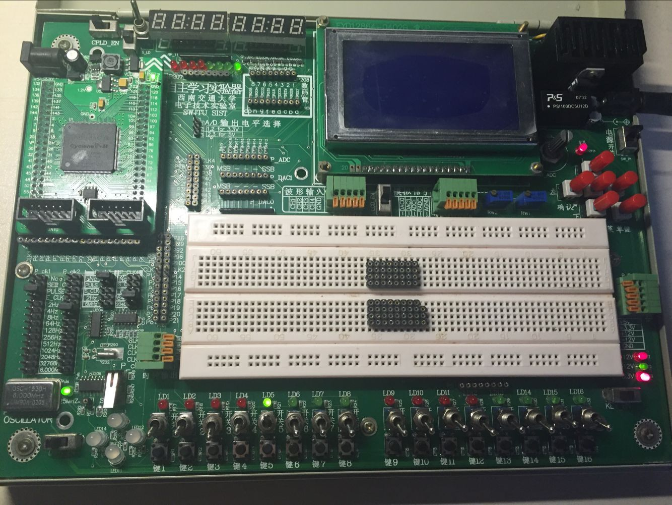

向东走一步来到隧道：

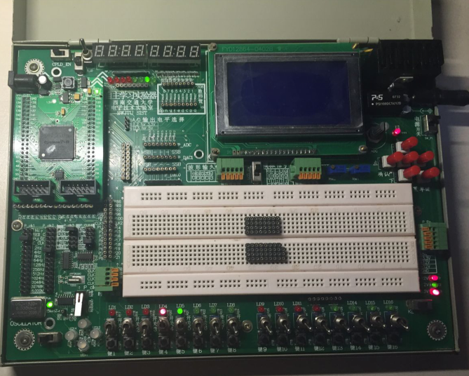

向南走一步，来到河流：

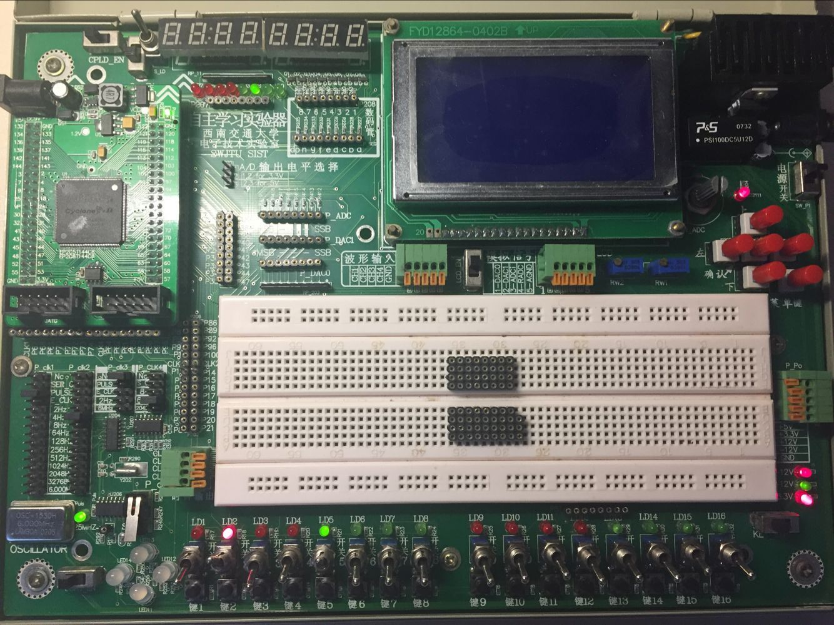

向西走一步来到藏剑阁：

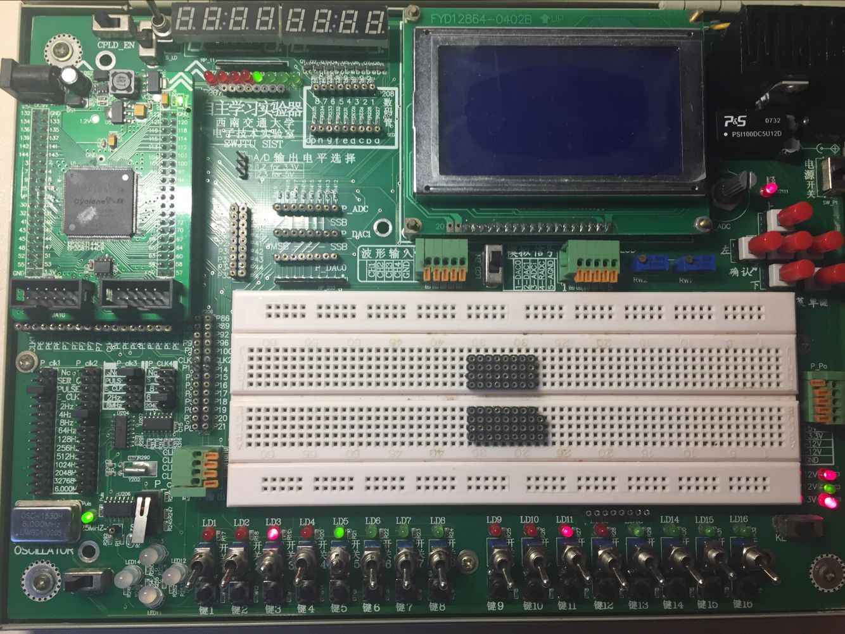

拿到剑：

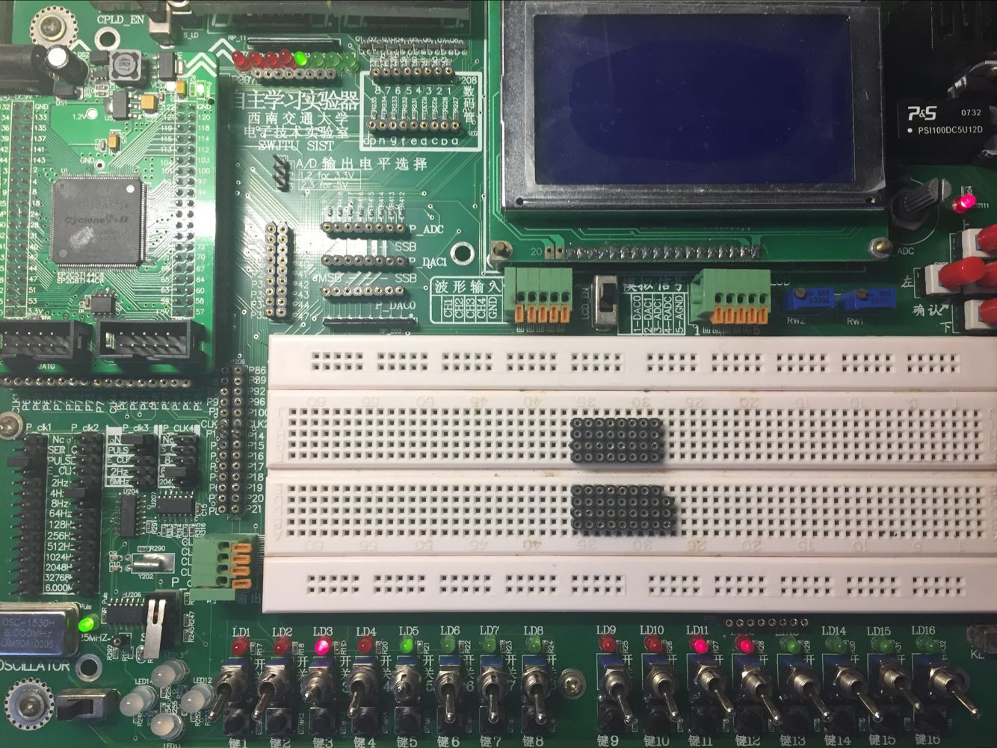

向东走一步，回到河流:

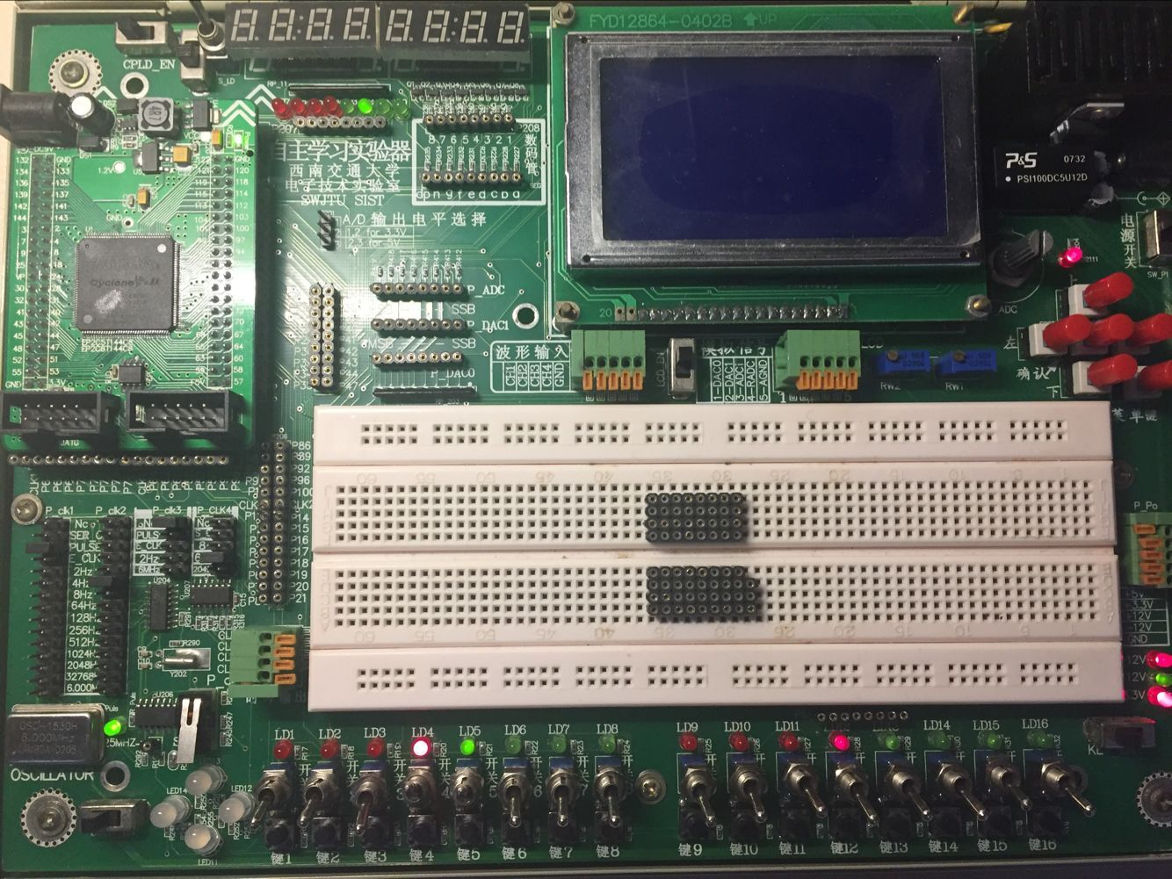

再向东走一步来到龙穴：

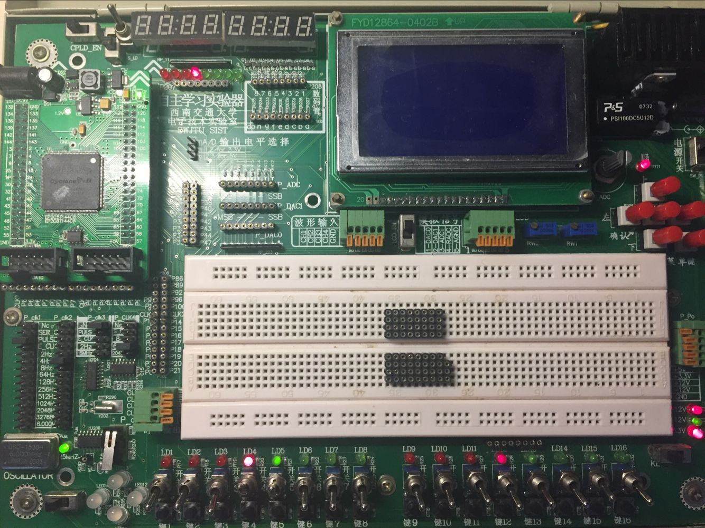

因为拿到剑了所以杀掉龙啦，you win~

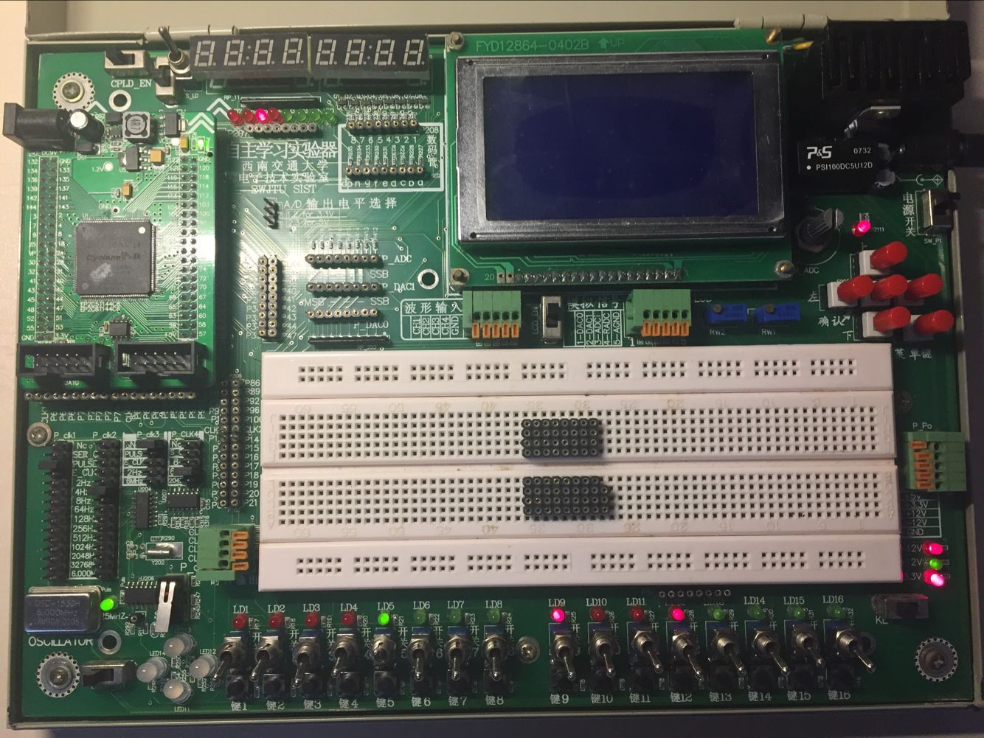

这是来到河流之后没有向西走去拿剑，直接向东走去徒手杀恶龙的..结果：

空手来到龙穴：

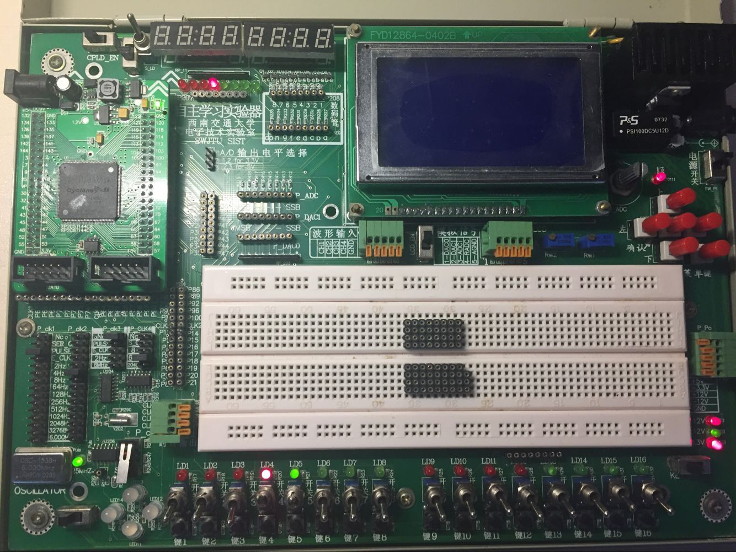

扑。街。Dead：game over

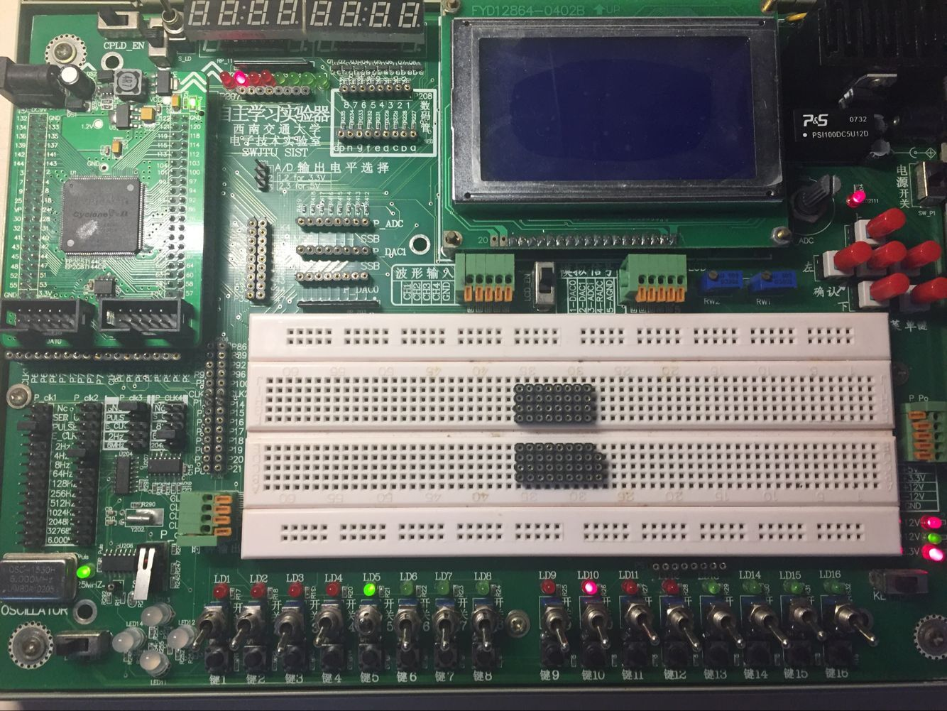

附件：

**Room: //房间状态机**

module Room(clk,n,s,e,w,v,reset,s6,win,s5,d,s4,s3,sw,s2,s1,s0);

input clk,n,s,e,w,v,reset;

output reg win,d,sw,s6,s5,s4,s3,s2,s1,s0;

reg [2:0]now,next;

parameter r0=3'b000,r1=3'b001,r2=3'b010,r3=3'b011,r4=3'b100,r5=3'b101,r6=3'b110;

always @(posedge clk,negedge reset)

begin

if (~reset)

begin

next<=r0;

now<=r0;

sw<=1'b0;

end

else

//begin

now<=next;

case (now)

r0: begin

s0<=1'b1;

s1<=1'b0;

s2<=1'b0;

s3<=1'b0;

s4<=1'b0;

s5<=1'b0;

s6<=1'b0;

sw<=1'b0; win<=1'b0; d<=1'b0; if (e) next<=r1; else next<=now;

end

r1: begin

s0<=1'b0;

s1<=1'b1;

s2<=1'b0;

s3<=1'b0;

s4<=1'b0;

s5<=1'b0;

s6<=1'b0;

sw<=1'b0; win<=1'b0; d<=1'b0; if (w) next<=r0; else if (s) next<=r2; else next<=r1;

end

r2: begin

s0<=1'b0;

s1<=1'b0;

s2<=1'b1;

s3<=1'b0;

s4<=1'b0;

s5<=1'b0;

s6<=1'b0;

sw<=1'b0; win<=1'b0; d<=1'b0; if (n) next<=r1; else if (w) next<=r3; else if (e) next<=r4; else next<=now;

end

r3: begin

s0<=1'b0;

s1<=1'b0;

s2<=1'b0;

s3<=1'b1;

s4<=1'b0;

s5<=1'b0;

s6<=1'b0;

sw<=1'b1; win<=1'b0; d<=1'b0; if (e) next<=r2; else next<=now;

end

r4: begin

s0<=1'b0;

s1<=1'b0;

s2<=1'b0;

s3<=1'b0;

s4<=1'b1;

s5<=1'b0;

s6<=1'b0;

sw<=1'b0; win<=1'b0; d<=1'b0; if (v) next<=r5; else next<=r6;

end

r5: begin

s0<=1'b0;

s1<=1'b0;

s2<=1'b0;

s3<=1'b0;

s4<=1'b0;

s5<=1'b1;

s6<=1'b0;

sw<=1'b0; win<=1'b1; d<=1'b0; next<=now;

end

r6: begin

s0<=1'b0;

s1<=1'b0;

s2<=1'b0;

s3<=1'b0;

s4<=1'b0;

s5<=1'b0;

s6<=1'b1;

sw<=1'b0; win<=1'b0; d<=1'b1; next<=now;

end

endcase

//end

end

endmodule

**Sword: //斩首剑状态机**

module sword(sw,reset,clk,V);

input sw,reset,clk;

output V;

reg V=0;

always @ (posedge clk, negedge reset)

begin

if (~reset) V<=1'b0;

else begin

if (sw) V<=1'b1;

else V<=V;

end

end

endmodule

**梁祝蜂鸣器：**

module liangzhu(clk_50M,rst,speaker);

input clk_50M,rst;

output speaker;

reg speaker;

//分频计数器

parameter wide=15;

reg[7:0] cnt; //音名数

reg[3:0] cnt1; //5MHz基频

reg[23:0] cnt2;//节拍频率5Hz

reg[wide-1:0] origin;//预置数寄存器

reg[wide-1:0] drive;

reg[1:0] count;

reg carrier;

//分频产生5MHz和5Hz的频率

always @(posedge clk_50M,negedge rst)

begin

if(!rst)

begin

cnt1<=4'd0;

cnt2<=24'd0;

end

else

begin

cnt1<=cnt1+1'b1;

cnt2<=cnt2+1'b1;

if(cnt1==4'd9)

cnt1<=4'd0;

if(cnt2==24'h98967F)

cnt2<=24'd0;

end

end

always @(posedge clk_50M,negedge rst)

begin

if(!rst)

drive<=15'h0;

else if(cnt1==4'd9)

begin

if(drive==15'h7fff)

begin

drive<=origin;

carrier<=1'b1;

end

else begin drive<=drive+1'b1;carrier<=1'b0; end

end

end

//carrier的频率是每个音阶的频率

always @(posedge carrier)

begin

count<=count+1'b1;

if(count==4'd0)

speaker<=1'b1;

else speaker<=1'b0;

end

always @(posedge clk_50M,negedge rst)

begin

if(!rst)

begin

origin<=15'h0;

cnt<=8'd0;

end

else if(cnt2==24'h98967F)

begin

if(cnt==8'd139)

cnt<=8'd0;

else

cnt<=cnt+1'b1;

case (cnt)

8'd0:origin<=15'h625F; //中音3，4个节拍

8'd1:origin<=15'h625F;

8'd2:origin<=15'h625F;

8'd3:origin<=15'h625F;

8'd4:origin<=15'h6715; //中音5,3个节拍

8'd5:origin<=15'h6715;

8'd6:origin<=15'h6715;

8'd7:origin<=15'h69cd;//中音6

8'd8:origin<=15'h6d55; //高音1，3个节拍

8'd9:origin<=15'h6d55;

8'd10:origin<=15'h6d55;

8'd11:origin<=15'h6f5f; //高音2

8'd12:origin<=15'h69cd; //中音6

8'd13:origin<=15'h6d55; //高音1

8'd14:origin<=15'h6715; //中音5

8'd15:origin<=15'h6715;

8'd16:origin<=15'h738a; //高音5

8'd17:origin<=15'h738a;

8'd18:origin<=15'h738a;

8'd19:origin<=15'h76aa; //倍高音1

8'd20:origin<=15'h69cd; //高音6

8'd21:origin<=15'h6715;//高音5

8'd22:origin<=15'h712f;//高音3

8'd23:origin<=15'h6715;//高音5

8'd24:origin<=15'h6f5f; //高音2

8'd25:origin<=15'h6f5f;

8'd26:origin<=15'h6f5f;

8'd27:origin<=15'h6f5f;

8'd28:origin<=15'h6f5f;

8'd29:origin<=15'h6f5f;

8'd30:origin<=15'h6f5f;

8'd31:origin<=15'h6f5f;

8'd32:origin<=15'h6f5f;

8'd33:origin<=15'h6f5f;

8'd34:origin<=15'h6f5f;

8'd35:origin<=15'h712f;//高音3

8'd36:origin<=15'h6c39; //中音7

8'd37:origin<=15'h6c39;

8'd38:origin<=15'h69cd;//中音6

8'd39:origin<=15'h69cd;

8'd40:origin<=15'h6715; //中音5

8'd41:origin<=15'h6715;

8'd42:origin<=15'h6715;

8'd43:origin<=15'h69cd;//中音6

8'd44:origin<=15'h6d55;//高音1

8'd45:origin<=15'h6d55;

8'd46:origin<=15'h6f5f;//高音2

8'd47:origin<=15'h6f5f;

8'd48:origin<=15'h625f;//中音3

8'd49:origin<=15'h625f;

8'd50:origin<=15'h6d55; //高音1

8'd51:origin<=15'h6d55;

8'd52:origin<=15'h69cd;//中音6

8'd53:origin<=15'h6715;//中音5

8'd54:origin<=15'h69cd; //中音6

8'd55:origin<=15'h6d55;//高音1

8'd56:origin<=15'h6715;//中音5

8'd57:origin<=15'h6715;

8'd58:origin<=15'h6715;

8'd59:origin<=15'h6715;

8'd60:origin<=15'h6715;

8'd61:origin<=15'h6715;

8'd62:origin<=15'h6715;

8'd63:origin<=15'h6715;

8'd64:origin<=15'h712f;//高音3

8'd65:origin<=15'h712f;

8'd66:origin<=15'h712f;

8'd67:origin<=15'h738a;//高音5

8'd68:origin<=15'h6c39;//中音7

8'd69:origin<=15'h6c39;

8'd70:origin<=15'h6f5f;//高音2

8'd71:origin<=15'h6f5f;

8'd72:origin<=15'h69cd; //中音6

8'd73:origin<=15'h6d55;//高音1

8'd74:origin<=15'h6715;//中音5

8'd75:origin<=15'h6715;

8'd76:origin<=15'h6715;

8'd77:origin<=15'h6715;

8'd78:origin<=15'h6715;

8'd79:origin<=15'h6715;

8'd80:origin<=15'h625f; //中音3

8'd81:origin<=15'h6715;//中音5

8'd82:origin<=15'h625f;//中音3

8'd83:origin<=15'h625f;

8'd84:origin<=15'h6715;//中音5

8'd85:origin<=15'h69cd;//中音6

8'd86:origin<=15'h6c39;//中音7

8'd87:origin<=15'h6f5f;//高音2

8'd88:origin<=15'h69cd;//中音6

8'd89:origin<=15'h69cd;

8'd90:origin<=15'h69cd;

8'd91:origin<=15'h69cd;

8'd92:origin<=15'h69cd;

8'd93:origin<=15'h69cd;

8'd94:origin<=15'h6715;//中音5

8'd95:origin<=15'h69cd;//中音6

8'd96:origin<=15'h6d55;//高音1

8'd97:origin<=15'h6d55;

8'd98:origin<=15'h6d55;

8'd99:origin<=15'h6f5f;////高音2

8'd100:origin<=15'h738a; //高音5

8'd101:origin<=15'h738a;

8'd102:origin<=15'h738a;

8'd103:origin<=15'h712f;//高音3

8'd104:origin<=15'h6f5f;//高音2

8'd105:origin<=15'h6f5f;

8'd106:origin<=15'h712f;//高音3

8'd107:origin<=15'h6f5f;//高音2

8'd108:origin<=15'h6d55;//高音1

8'd109:origin<=15'h6d55;

8'd110:origin<=15'h69cd;//中音6

8'd111:origin<=15'h6715;//中音5

8'd112:origin<=15'h625f;//中音3

8'd113:origin<=15'h625f;

8'd114:origin<=15'h625f;

8'd115:origin<=15'h625f;

8'd116:origin<=15'h6d55;//高音1

8'd117:origin<=15'h6d55;

8'd118:origin<=15'h69cd;//中音6

8'd119:origin<=15'h6d55;//高音1

8'd120:origin<=15'h69cd;//中音6

8'd121:origin<=15'h625f;//中音3

8'd122:origin<=15'h625f;

8'd123:origin<=15'h6f5f;//高音2

8'd124:origin<=15'h625f;//中音3

8'd125:origin<=15'h6715;//中音5

8'd126:origin<=15'h69cd;//中音6

8'd127:origin<=15'h6d55;//高音1

8'd128:origin<=15'h6715;//中音5

8'd129:origin<=15'h6715;

8'd130:origin<=15'h6715;

8'd131:origin<=15'h6715;

8'd132:origin<=15'h6715;

8'd133:origin<=15'h6715;

8'd134:origin<=15'h6715;

8'd135:origin<=15'h6715;

8'd136:origin<=15'h3fff;

8'd137:origin<=15'h3fff;

8'd138:origin<=15'h3fff;

8'd139:origin<=15'h3fff;

default:origin<=15'h3fff;

endcase

end

end

endmodule